Chapter 7, Solution 10.

For t<0, 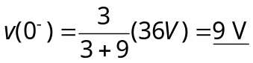
For t>0, we have a source-free RC circuit

v_{o}(t) = 9e^{–16.667t} V

Let the time be t_{o}.
3 = 9e^{–16.667to} or e^{16.667to} = 9/3 = 3

t_{o} = ln(3)/16.667 = 65.92 ms.

